Registration for Summer Programs

Student Name:

Please check appropriate circle:

- Special Camps (limited dates)
Cost $75
- Princess Camp – Jun 23-25
- Pop Star Camp – Jul 7-9
- Zootopia Camp – Aug 4-6
- Tricks and Turns Camp – Jul 7-9
Cost $25
- Magical Fairy Camp – Jun 27

- Session A (8-week course) Jun 8-Aug 6
Cost $100
- Barre/Flex (Thurs 6:00-7:00pm)
- Barre/Flex (Thurs 7:00-8:00pm)

- Session B (4-week course) Jun 8-Jul 2
Cost $50
- Musical Theater (Wed 5:30-6:15pm)
- Tap (Wed 6:15-7pm)
- Hip Hop (Wed 7-7:45pm)

- Session C (4-week course) Jul 13 – Aug 8
Cost $50
- Dance Exploration (Wed 5:30-6:15pm)
- Lyrical/Contemporary (Wed 6:15-7pm)
- Acro (Wed 7-7:45pm)
- Creative Movement (Sat 9:30-10:15am)

Please make checks payable to:
Legacy Dayton Dance Studio

Princess Camp
June 23, 24 and 25
10:00am – 11:30am
Ages 4-8
Students will not only learn a ballet dance to perform but they will also craft an outfit and accessories to wear for their performance.

Pop Star Camp
July 7, 8 and 9
5:00pm – 6:30pm
Ages 4-8
Students will learn a jazz dance and will get to help craft their outfit to wear for their performance.

Zootopia Camp
Aug 4, 5 and 6
10:00am – 11:30am
Ages 4-8
Students will explore tap dancing and learn a tap routine to perform as well as making some fun zoo animal themed crafts.

Camps are $75 each
or save and book all 3 for $200!

Fall Schedule will be posted on our website by July 15th

Fall classes begin on Sept 14, 2026

Have a wonderful and safe summer!!

Legacy Dayton Dance Studio

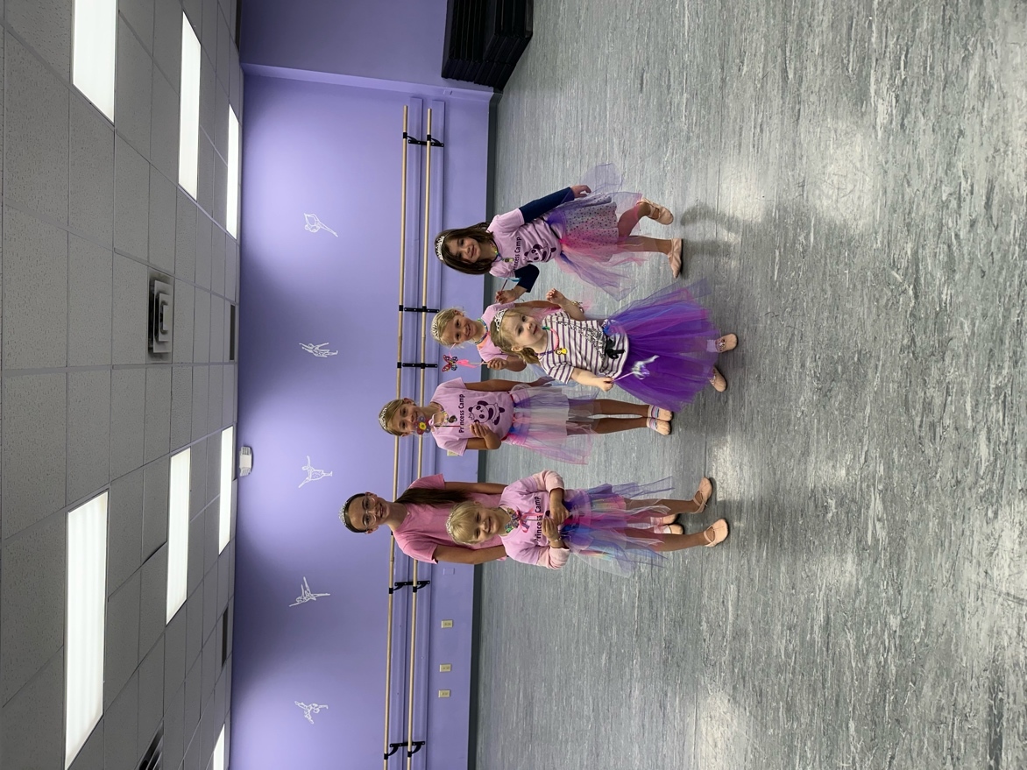

Summer Dance
Programs

2026

8100 Washington Village Dr
Washington Township, OH 45458
(937) 433-9650
www.legacydaytondance.com

Find us on Facebook and Instagram
to stay connected

Session A
8-week course
June 8 – Aug 6
(No classes July 6-9)
Classes are $100 for the session

Barre and Flexibility
Ages 8-13
Thursdays from 6:00pm to 7:00pm
Focus will be on technique and strengthening through barre work along with stretching and joint mobility.

Barre and Flexibility
Ages 14 and up
Thursdays from 7:00pm to 8:00pm
Focus will be on technique and strengthening through barre work along with stretching and joint mobility.


Tricks & Turns Camp
July 7, 8 and 9
6:30-8:00pm
Ages 9-18
$75
Students will focus on technique and strength to improve upon various skills, tricks and turns.

Session B
4-week course
June 8 – July 2
Classes are $50 for the session

Musical Theater
Ages 10 and up
Wednesdays from 5:30pm to 6:15pm
Designed for dancers with all levels of experience. Students will work on adding character to their movement.

Tap
Ages 10 and up
Wednesdays from 6:15pm to 7:00pm
Designed for dancers with all levels of experience. Students will work on musicality and rhythm.

Hip Hop
Ages 10 and up
Wednesdays from 7:00pm to 7:45pm
Designed for students with all levels of experience.


Magical Fairy Camp
Sat, June 27
10:00am – 11:30am
Ages 2-4
$25
Students will explore movement through music and rhythm introducing dance moves with a fairy theme. Students will also do some fairy themed crafts.

Session C
4-week course
July 13 – Aug 8
Classes are $50 for the session

Dance Exploration
Ages 5-10
Wednesdays from 5:30pm to 6:15pm
Designed for students with some dance experience as well as those new to dance. Students will explore ballet, tap, jazz, lyrical, hip hop and acro.

Lyrical / Contemporary
Ages 10 and up
Wednesdays from 6:15pm to 7:00pm
Designed for dancers with all levels of experience.

Acro
Ages 10 and up
Wednesdays 7:00pm to 7:45pm
Designed for students with all levels of experience. Students will work on strength and flexibility.

Creative Movement
Ages 2-4
Saturdays from 9:30am to 10:15am
This is an introductory class for preschool age students. We will explore movement through music and rhythm introducing beginning dance moves along the way.

Stay active this summer!!

